1 .What is multiplexer?
- Multiplexer is a digital switch which allows digital information from several sources to be routed onto a single output line. Basic multiplexer has several data inputs and a single outputline.
- The selection of a particular input line is controlled by a setof selectionline.
- There are 2^{n} input lines & n is the number of selection line whose bit combinations determines which input is selected .It is ―Many into One‖.
- Strobe: - It is used to enable/ disable the logic circuit OR‗E‘ iscalled as enable I/P which is generally active LOW. It is used forcascading
- MUX is a single pole multiple wayswitch.

Necessity ofmultiplexer
  - In most of the electronic systems, digital data is available on morethan one lines. It is necessary to route this data over a singleline.
  - It select one of the many I/P at atime.
  - Multiplexer improves the reliability of digital system because it reduces the number of external wireconnection.

Enlist significance and advantages ofMultiplexer

- It doesn‘t need K-map & logicsimplification.
- The IC package count isminimized.
- It simplifies the logicdesign.
- In designing the combinationalcircuit
- It reduces the complexity &cost.
- To minimize number of connections in communication system were we need to handle thousands of connections. Ex. Telephoneexchange.

Applications ofMUX
- Data selector to select one out of many dataI/P.
- In Data Acquisitionsystem.
- In the D/Aconverter.

Multiplexer Tree
- It is nothing but construction of more number of line usingless number oflines.
- It is possible to expand the range of inputs for multiplexers beyond the available Range in the integrated circuits. This can be accomplished by interconnecting severalmultiplexers.

8:1 MUX:
The block diagram of 8:1 MUX & its TT is shown. It has eight data I/P & one enable input, three select lines and one O/P.

Operating principle:
When the Strobe or Enable input is active low, we can select any one of eight data I/P and connect to O/P.

Design:

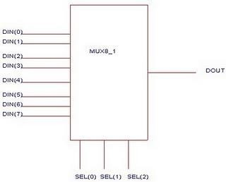

Draw the connection diagram of multiplexer to verify the functional table.

SELECTION LINES |  |  | STROBE | OUTPUTS
C | B | A | E | Y | Y
X | X | X | 1 | 0 | 1
0 | 0 | 0 | 0 | D0 | D0
0 | 0 | 1 | 0 | D1 | D1
0 | 1 | 0 | 0 | D2 | D2
0 | 1 | 1 | 0 | D3 | D3
1 | 0 | 0 | 0 | D4 | D4
1 | 0 | 1 | 0 | D5 | D5
1 | 1 | 0 | 0 | D6 | D6
1 | 1 | 1 | 0 | D7 | D7

X = don’t care condition.

Part 1: MUX as a function generator.

Convert the given Boolean expression into standard SOP / POS format if required and complete the logic diagram design accordingly for realization of the same.

As anexample:

Function = Sum of Product (SOP)
Y = ∑m (1, 2, 3, 4, 5, 6, 7)

SELECTION LINES |  |  | STROBE | OUTPUTS
C | B | A | 1 | Y | Y
0 | 0 | 0 | 0 | 0 | 1
0 | 0 | 1 | 0 | 1 | 0
0 | 1 | 0 | 0 | 1 | 0
0 | 1 | 1 | 0 | 1 | 0
1 | 0 | 0 | 0 | 1 | 0
1 | 0 | 1 | 0 | 1 | 0
1 | 1 | 0 | 0 | 1 | 0
1 | 1 | 1 | 0 | 1 | 0

SOP realization Diagram

SOP Y = ∑m (1, 2, 3, 4, 5, 6,7)

Solution:-Since there are 3 variable, the multiplexer have 3 select I/P should be used. Hence one 8:1 mux should be used.
Ste p 1:-Identify the number decimal corresponding to each minterm.
Here1,2,3,4,5,6,7
Step 2:-Connect the data input lines 1,2,3,4,5,6,7 to logic 1(+Vcc) & remaining inputline 0 to logic0(GND)
Step 3:-Connect variables A, B & C to select input.

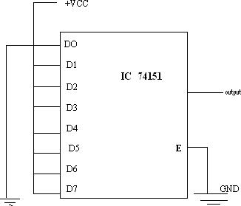

As an example Function = Product of Sum(POS)
Y = ∏ M (0, 5, 6, 7)

SELECTION LINES |  |  | STROBE | OUTPUTS
C | B | A |  | Y | Y
0 | 0 | 0 | 0 | 0 | 1
0 | 0 | 1 | 0 | 1 | 0
0 | 1 | 0 | 0 | 1 | 0
0 | 1 | 1 | 0 | 1 | 0
1 | 0 | 0 | 0 | 1 | 0
1 | 0 | 1 | 0 | 0 | 1
1 | 1 | 0 | 0 | 0 | 1
1 | 1 | 1 | 0 | 0 | 1

POS realization exp:
- As there are 3 i/p so use 8:1MUX
- Connect the given min terms to GND and else decimal numbers tologic1(+VCC).

POS realization Diagram

POS Y = ∏ M (0, 5, 6,7)
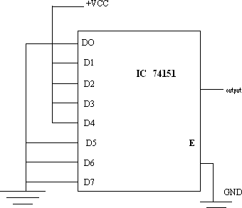

Part -2: Implementation of 16:1 MUX using 8:1 MUX

Second method: F (A, B, C, D) = ∑m (2, 4, 6, 7, 9, 10, 11, 12, 15)

- Make a combination of pair according to same Values of A, B andC
- Check the output values with respect to value of D.

A | B | C | D | output | output
0 | 0 | 0 | 0 | 0 | 0
0 | 0 | 0 | 1 | 0 | 0
0 | 0 | 1 | 0 | 1 | ‾  D
0 | 0 | 1 | 1 | 0 | ‾  D
0 | 1 | 0 | 0 | 1 | ‾  D
0 | 1 | 0 | 1 | 0 | ‾  D
0 | 1 | 1 | 0 | 1 | 1
0 | 1 | 1 | 1 | 1 | 1
1 | 0 | 0 | 0 | 0 | D
1 | 0 | 0 | 1 | 1 | D
1 | 0 | 1 | 0 | 1 | 1
1 | 0 | 1 | 1 | 1 | 1
1 | 1 | 0 | 0 | 1 | ‾  D
1 | 1 | 0 | 1 | 0 | ‾  D
1 | 1 | 1 | 0 | 0 | D
1 | 1 | 1 | 1 | 1 | D

16:1 MUX using 8:1 MUX Diagram: Second Method

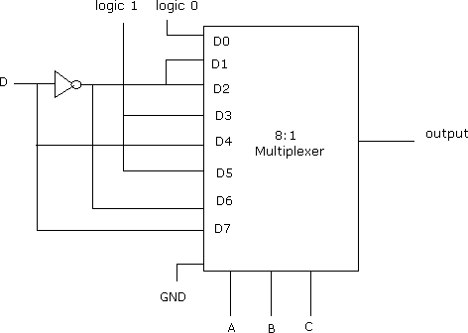

Part-3 Implementation of 16:1 MUX using two 8:1 MUX (Cascading Method)

F(A,B,C,D)= ∑m(2, 4, 5, 7, 10, 14)
Solution:-

Step 1: Connect S2, S1, S0 select lines of two 8:1 MUX parallel where as MSB select input is used for enabling MUX.
Step 2: S3 is connected directly to the enable (E) to mux-2whereas is connect to enable input ofmux-1
Step 3: The output of two MUX are OR to get final output.

Truth table: - PART_3

Select line |  |  |  | Output |  | Final Output
S3 | S2 | S1 | S0 | Y1 | Y2 | Y
0 | 0 | 0 | 0 | D0 | -- | D0
0 | 0 | 0 | 1 | D1 | -- | D1
0 | 0 | 1 | 0 | D2 | -- | D2
0 | 0 | 1 | 1 | D3 | -- | D3
0 | 1 | 0 | 0 | D4 | -- | D4
0 | 1 | 0 | 1 | D5 | -- | D5
0 | 1 | 1 | 0 | D6 | -- | D6
1 | 1 | 1 | 1 | D7 | -- | D7
1 | 0 | 0 | 0 | -- | D8 | D8
1 | 0 | 0 | 1 | -- | D9 | D9
1 | 0 | 1 | 0 | -- | D10 | D10
1 | 0 | 1 | 1 | -- | D11 | D11
1 | 1 | 0 | 0 | -- | D12 | D12
1 | 1 | 0 | 1 | -- | D13 | D13
1 | 1 | 1 | 0 | -- | D14 | D14
1 | 1 | 1 | 1 | -- | D15 | D15

Truth Table for 16:1 MUX using two 8:1 MUX

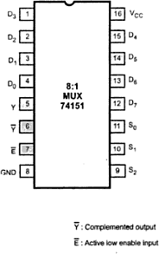
Pin Diagram
IC 74151

8:1 mux

Multiplexer Tree according to given equation:-

